**COOKING FRIED RICE**

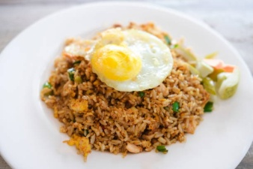

**Ingredients:**

1. White rice 1 plate

2. Garlic 2 cloves, finely chopped

3. Sweet soy sauce or salty soy sauce according to taste

4. Chili sauce according to taste

5. Oyster sauce according to taste

6. Salt to taste

7. Broth powder with chicken or beef flavor according to taste

8. Leek 1 stem, finely chopped

9. Chicken eggs 1 item

10. Chicken sausage 1 piece, thinly sliced

11. Margarine or cooking oil 3 tbsp

**How to make :**

1. Prepare a frying pan over medium heat, pour margarine or cooking oil.

2. Add the finely chopped garlic and chives. 3. Sauté until fragrant or golden in color.

4. Add sausage and 1 chicken egg. Saute for a minute.

5. Enter the ground spices and rice. Stir until well mixed.

6. Pour the sweet soy sauce, chili sauce, oyster sauce, salt, and powdered stock. 7. Stir until the color of the rice changes evenly.

Simple and delicious plain fried rice is ready to be served.